Alastair Ibrahim II
JOU3346L
Field Assignment 4

Some Walmart shoppers in Gainesville, FLA. feel unsafe when shopping for their groceries.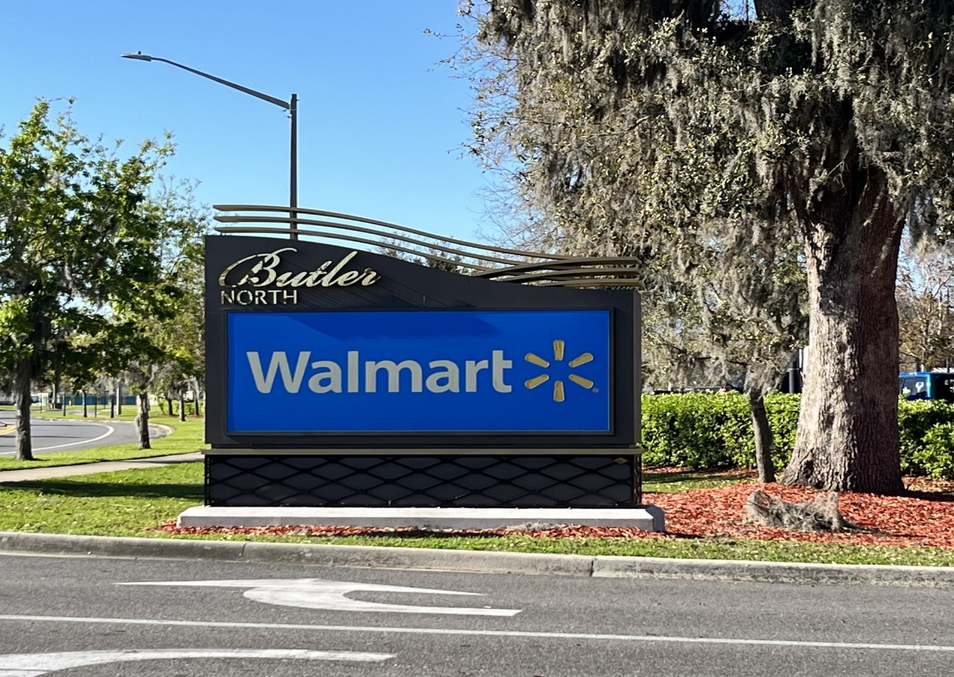
Gainesville, FLA.- Some shoppers at the Butler North Walmart in Gainesville, FLA. feel uneasy when shopping in the stores due to some of the incidents that have occurred there in the recent past.
Walmart is a store in which many are very familiar with. The store sells clothing, grocery items, and household accessories which makes it a one-stop shop for shoppers needs. Generally speaking, most Walmarts are the same with the same items, same layouts and same service. Another thing that tends to be consistent with Walmarts around the United States of America is their ability to attract gun violence.
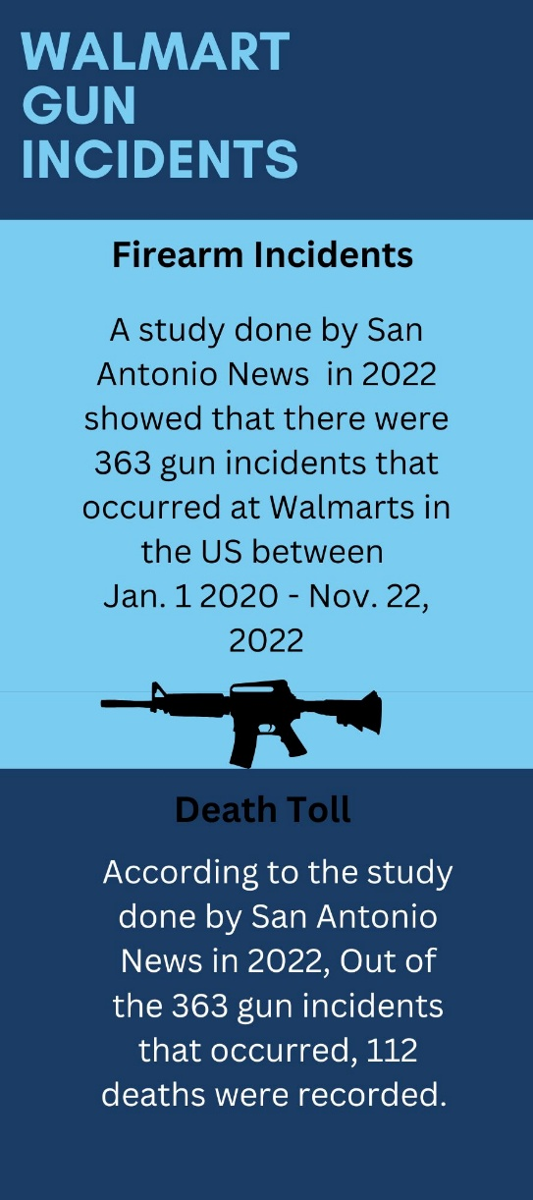
On March 1, 2025 an armed woman was arrested after shooting multiple shots outside of the Butler North Walmart. The woman was armed with multiple firearms and was taken into custody after a stand-off with law enforcement that lasted for approximately five hours. Parts of the Butler North Walmart were evacuated during the incident; however, some shoppers were forced to stay inside of the store until the stand-off between law enforcement and the suspect was over and the suspect was in custody. No one was injured in the incident; however, many Walmart shoppers are still reluctant to shop at the Butler North Walmart.
Olivia Silvers does her shopping at the Butler North Walmart and has lived in Gainesville, FLA. for seven years. She has not been back to the Butler North Walmart since the gun incident occurred.
“I don’t think I have ever felt 100% safe going to that Walmart, even before this incident.” Silvers said. “It’s always had bad management, and they don’t have the best customer service. I can say that I have not been back to any Walmart since that incident that happened a few weeks ago. I wasn’t there for it, but the news gets around and I am definitely scared to shop there now.”
Many Butler North Walmart shoppers worry about the safety of their families when they make the decision to shop. Butler North Walmart shopper Matthew Olsen understands that anything can happen anywhere, but he feels that Walmarts nationwide could have better security in place.
“I understand that incidents can happen anywhere at any time.” Olsen said. “I just feel like you hear about incidents like that happening at Walmart all the time. I stopped bringing my family here when I come to shop because I don’t want them to have to go through a stressful and dangerous situation. I just feel like Walmart as a company should see the pattern of violent things happening in their stores and step up their security some.”
Some shoppers have boycotted the Butler North Walmart due to the incident that occurred at the beginning of March. Alexandra Payne is a student at the University of Florida who has lived in Gainesville for 10 months. She was shocked when she heard about the incident occurred yet has no plans of going back to the Butler North Walmart anytime soon.
“I went there because it is only five minutes away from my apartment.” Payne said. “After hearing what happened, I don’t really have any plans on going back until I feel like its settled down. I always noticed that they had little to no security there and I feel like if they had more, I would feel safer. I have just been going to Aldi and Publix for the past couple of weeks and I probably will keep doing that for a while.”
Some shoppers feel that they need to use their own devices to protect themselves while shopping at the Butler North Walmart. Nathaniel Malone says that he has peace in knowing that he has taken an extra step for the safety of himself and his family.
“When I heard about the incident that happened a few weeks ago, I wasn’t surprised at all.” Malone said. “The whole country has gotten to the point where even the nice areas of town are dangerous. I personally have my concealed weapons permit, and I carry daily which really helps put my mind at ease when I hear about incidents like the one that happened here. I at least know that if something were to happen and I am there, I have a way to protect myself, my family and others.”
Walmarts nationwide have been known to have their issues with gun violence. Many shoppers are upset and feel unsafe in some of their stores which has resulted in them taking their business elsewhere.

Captions:

Photo 1: Butler North Walmart entrance sign at the Butler Walmart in Gainesville, FLA. 2900 SW 42nd St. Gainesville, FLA. 32608
Infographic: Infographic on gun incidents at Walmart from 2020 to 2022.

Sources:
Olivia Sivers: Phone: (352) 505-2811
Matthew Olsen: Phone: (352) 441-0395
Alexandra Payne: (863) 214-5952
Nathaniel Malone: (352) 633-0029

